Oyster Task Force Meeting Minutes
Tuesday, May 14, 2019, 1:00p.m.
St. Bernard Port Harbor and Terminal
100 Port Blvd., Chalmette, LA 70043

I. Pledge of Allegiance
II. Roll call and introduction of guests

Voting Members Present:
Shane Bagala
Dan Coulon
Byron Encalade
Jakov Jurisic
Mitch Jurisich
Brad Robin
Brandt Lafrance
John Tesvich
Sam Slavich
Peter Vujnovich

Voting Members Absent:
Tracy Collins
Leo Dyson
Al Sunseri
Willie Daisy

Non-voting Members Present:
Carolina Bourque
Justin Gremillion
Edward Skena
Frank Cole in for Karl Morgan

Non-voting Members Absent:
Brian Lezina

III. Jakov Jurisic motioned to approve the April 16, 2019 meeting minutes, 2nd by Peter Vujnovich. Motion carries.

Jakov Jurisic motioned to add an item to the agenda under ‘New Business’ and take it up as item, F. To Consider an Appeal to the Oyster Task Force to Support the Development of Oyster Industry Projects- John Zach Lea, 2nd by John Tesvich. Motion carries.

John Tesvich motioned to approve the agenda as amended, 2nd by Shane Bagala. Motion carries.

IV. Treasury Report
Remaining Fund Balance- $379,325
Remaining Fund Balance- $50,794

Total oyster tag sales in the month of April- 193,302

Peter Vujnovich motioned to approve the financial report as presented, 2nd by Byron Encalade. Motion carries.

V. Committee Reports

- Public and Private Oyster Seed Grounds Committee- no report
- Enforcement Report- April 11th – May 8th
Region 4 (Iberia)
None

Region 5 (Iberia)
2 – Harvest Oysters from Unmarked Lease
1 – Violate sanitation code
Oysters seized- 34 Sacks

Region 6: (Terrebonne, Lafourche, Grand Isle)
Terrebonne (Sister Lake)
1– Take oysters no comm. license.
1 –Take oyster no gear.
1– Take oysters no oyster harvester lic.
3– Take oysters closed season Sister Lake.
3– Take oysters illegal hrs.
2– Violate sanitation code Log Book.
1– Take oysters illegal gear Diving device.

Oyster/Gear seized:
2 Dredge seized
25 sacks

Region 8: (Jefferson, Plaquemines, St. Bernard, Orleans, St. Tammany)
St Bernard
3 – Fail to land Oysters in Louisiana or Violate VMS Regs
Oysters seized - 403 mini sacks

Plaquemines
1– Fail to have scrapper license in possession
1– Fail to have number on top of vessel (Warning)

The task force requested for LDWF Enforcement to provide feedback on the prosecution of oyster related cases; LDWF Enforcement later notified the task force that they may be able to follow up on some cases of interest at the request of the task force, however, they would not have the personnel and time available to follow up on every case

- Legislative Committee Report- 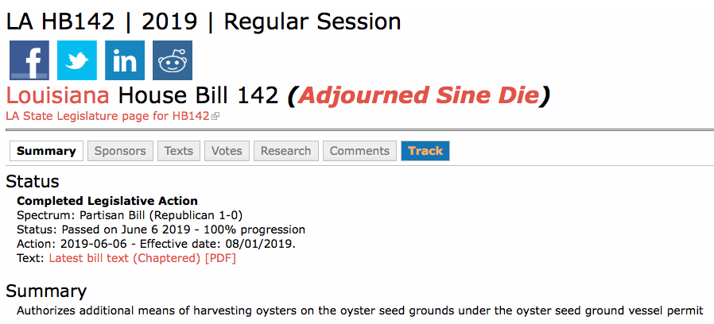

- Research Committee- No report

- Coastal Restoration Committee- No report

- Marketing Committee- No report- Jakov Jurisic made an announcement that his appointment as the OTF representative on the LA Seafood Promotion and Marketing Board is pending confirmation from the Senate Boards and Commissions Office

- Health Committee- Due to the high levels of the MS River, and diversions such as Mardi Gras Pass, the Health Department is going to initiate precautionary closures of Areas 7 and 8 starting at sundown on Wednesday, May 15, 2019. LDH will continue environmental sampling and will reopen as long as samples come back clear since this is just a precautionary closure. Parish President Guy McInnis stated that St. Bernard Parish has declared a state of emergency in regards to the fresh water intrusion and is working with the LDWF and USDA to figure out what the oyster industry has to do to receive resources down the line through the USDA Farm Bill

Carolina Bourque stated that in the MS Sound area, close to Lake Borgne, the temps have been rising- almost reaching 80 degrees, salinities since April have been between 0 and 0.5 PPT; The Grand Pass area is back to 6 PPT (salinity readings taken from the top)

- Professionalism Committee- No report

- Aquaculture Committee- No report

- Joint Task Force Working Group- No report

VI. New Business

- Carolina Bourque provided the task force with an update on the 2018-19 oyster season

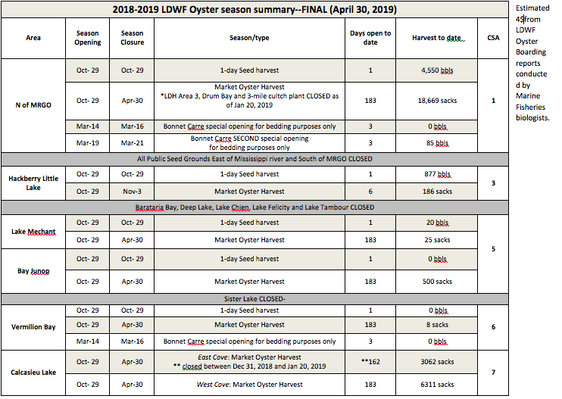

Recent oyster mortality in the Bonne Carre Spillway area has been low, samples were collected yesterday after temperatures were high and there are two sample sides that are not looking good as of right now and those are Grassy and Round Island. LDWF biologists observed between seed and sack around 86 percent mortality in Grassy Island and an average of 25 percent mortality in the Round Island area. Areas Grand Banks and further east are still holding on good

The board asked that LDWF continue to sample and monitor throughout the summer

Jakov Jurisic motioned to recommend that LDWF establish additional sampling stations in the general Grand Banks area from Cabbage Reef to Turkey Bayou, 2nd Sam Slavich. Motion carries.

- John Tesvich motioned to postpone item B., ‘To Hear Discussion and an Update on the Oyster Lease Moratorium Lifting NOI’ until a meeting where the Office of State Lands can be in attendance to provide feedback and answer the board’s questions regarding this item, 2nd Brad Robin. Motion carries.

- Thomas Hymel, of LA Sea Grant, provided an update on the LA Fisheries Forward activities and the 2020 LA Seafood Summit

The 2020 LFF Summit is set for March 11, 2020 at the Pontchartrain Center in Kenner

Jakov Jurisic motioned to provide $5,000 to the LA Fisheries Forward Summit, 2nd by Peter Vujnovich. Motion carries.

- Earl Melancon led discussion on the request for letters of support for research proposals

The task force considered a resolution of support for a research proposal titled, ‘ Managing Genetic Resources for The U.S. Gulf of Mexico Oyster Aquaculture Industry: A Comprehensive Integrated Approach to Sustainable Genetic Improvement

Five- Year Project (2019-2024)
- Job 1: Identify and produce spatial maps of oyster resource zones, characteristics, and tools to predict oyster performance under different environmental conditions- all Gulf States
- Job 2: Develop and produce improved broodstock populations.
- Job 3: Field test and make improved genetic resources (i.e. gennplasm, brookstock populations) available to oyster industry (e.g., hatcheries, farmers)- performed in Louisiana and Alabama.
- Job 4: Develop repository and database for germplasm with genetic traits x environmental characteristics.

The task force didn’t feel they were given enough time to vet the proposal provided the timeframe for its submission; suggested sending the proposal to committee for further discussion prior to writing a letter of support

John Tesvich to send the proposal titled, ‘A Comprehensive Integrated Approach to Sustainable Genetic Improvement’ to the Research Committee for further discussion, 2nd by Jakov Jurisic.

Earl Melancon stated that Gulf States Marine Fisheries Commission will announce the recipient of the money in June 2019, with work slated to begin at the start of 2020

Byron Encalade stated that he had confidence in the project moving forward and urged that the task force provide their support

John Tesvich moved to amend the motion on the floor by inserting the words ‘in conjunction with the Aquaculture Committee’ after ‘the Research Committee’, 2nd by Jakov Jurisic. Motion carries, amendment adopted.

The chairman called the question on the adoption of the pending main motion as amended, “To send the proposal titled, ‘A Comprehensive Integrated Approach to Sustainable Genetic Improvement’ to the Research Committee in conjunction with the Aquaculture Committee for further discussion. Motion carries with 1 opposition- Byron Encalade.

The task force considered a resolution of support for a research proposal titled, ‘Helping Louisiana’s Oyster Fishery Adapt Through Coupled Social Ecological Vulnerability and Risk Assessment’

Two-Year Project (2020-2022)
- Quantify the exposure of the oyster fishery social-ecological system to sediment diversion (i.e. disturbance) in select oyster communities within the Delta region of Louisiana
- Determine the social and ecological vulnerability to sediment diversions as a combination of the select communities
- Susceptibility to (sensitivity), and
- Ability to cope with or respond to (adaptive capacity) potential harm
- Compare hypothesized impacts brought about by the planned sediment diversions across and within communities based on combining obj. A and B into spatially explicit risk profiles

Project rationale:
This work will strengthen the Louisiana Seafoods Future (LSF) mission by providing specific risk profiles that can be used for targeted adaptation planning across heterogeneous communities and occupational roles. This approach, created by the UN Intergovernmental Panel on Climate Change, acknowledges that risk-informed adaptation and mitigation planning will be essential in deltas

The task force suggested that they would need more time to vet the proposal before writing a letter of support

John Tesvich motioned to send the proposal titled, ‘Helping Louisiana’s Oyster Fishery Adapt Through Coupled Social Ecological Vulnerability and Risk Assessment’ to the Research and Coastal Restoration Committees for further discussion, 2nd by Jakov Jurisic.

Earl Melancon stated that a letter of support, if written, would need to be submitted by May 29th

Sam Slavich expressed concern with using the word adapt in the title, industry members felt this may give off the impression that the industry has viable options when in fact for some there are no options to adapt

The chairman called the question on the adoption of the pending motion made by John Tesvich and 2nd by Jakov Jurisic, ‘to send the proposal titled, ‘Helping Louisiana’s Oyster Fishery Adapt Through Coupled Social Ecological Vulnerability and Risk Assessment’ to the Research and Coastal Restoration Committees for further discussion, motion carries.

- Tom Hymel, of La Sea Grant, provided the board with information on an oyster industry marketing plan

The task force considered providing support for funding towards an oyster-industry marketing plan. The plan would cover the first year’s expenses to establish and operate social media sites, create and manage a website, media relations, and monthly featured stories by Ed Lallo

John Tesvich motioned to provide a cap of $50,000 in funding to support the oyster industry’s marketing plan, 2nd by Brad Robin. Motion carries.

- John Zach Lea presented the task force with an appeal to support the development of oyster industry enhancement projects

John Tesvich stated he agrees with Mr. Lea and that the oyster industry is of the belief that coastal areas can be rebuilt while also providing flood protection without devastating the fisheries. This idea has been stressed time and again at meetings and through letters and comments to different projects sponsored by the CPRA. Recommended that the task force write a letter of support for Mr. Lea’s efforts, supporting the overall concept, but remained that the task force’s support would be on a project-by-project basis. Suggested that the State invest resources in concepts and projects that protect the fisheries while also providing flood protection and coastal restoration, feel as though this idea should be a major plank in the state’s Master Plan, but never has been.

John Tesvich motioned to write a letter supporting Mr. John Zach Lea’s overall efforts in finding alternative methods of coastal restoration beyond fresh water diversions and the concept of supporting a strong oyster industry. Stressing the need for the State to invest resources to protect the fisheries along with providing for flood protection and coastal restoration. The letter, while expressing the task force’s support for the overall concepts and efforts presented by Mr. Lea, would reserve the support of any specific project to be taken up on a project-by-project basis. Additionally, the letter would express that these concepts are a clear example that CPRA has not considered or explored alternative methods of coastal restoration that would not devastate the fisheries, 2nd by Shane Bagala.

The board expressed concern with using oyster reefs as a coastal restoration tool, this can become an issue when the reef is turned into a sanctuary and resource is taken away from the oystermen, asked that Mr. Lea take this into account, stressing the importance of the task forces input on each project.

Mr. Lea to write project proposals for the task force’s consideration

Mitch Jurisich suggested that it might be more beneficial for the task force to consider project proposals for support as opposed to writing a vague letter of support for the concept and overall efforts

Jakov Jurisic requested that the chairman circulate the draft letter to the task force members prior to sending it

The chairman called the question on the adoption of the pending motion made by John Tesvich and 2nd by Shane Bagala, to write a letter supporting Mr. John Zach Lea’s overall efforts in finding alternative methods of coastal restoration beyond fresh water diversions and the concept of supporting a strong oyster industry. Stressing the need for the State to invest resources to protect the fisheries along with providing for flood protection and coastal restoration. The letter, while expressing the task force’s support for the overall concepts and efforts presented by Mr. Lea, would reserve the support of any specific project to be taken up on a project-by-project basis. Additionally, the letter would express that these concepts are a clear example that CPRA has not considered or explored alternative methods of coastal restoration that would not devastate the fisheries. Motion carries.

- Carolina Bourque provided the task force with a presentation and demonstration on the standardized method used in determining the percentage of the non-living material in bedding loads

VII. Public Comment-

Mitch Jurisich stated that due to the river levels and fresh water intrusion, he asked that the industry monitor and keep a close eye on the situation (die offs, etc.) in each parish and, based off of what is observed, following St. Bernard Parish in establishing a state of emergency if necessary. Would like to follow up at the next OTF meeting with a status report by area and depending on the situation, at that time, possibly reaching out to the governor

Announcement: LA Department of Wildlife and Fisheries is bringing oyster tag sales back to the New Orleans office. Sales will be done through the Oyster Lease Program. There is limited inventory, therefore it is preferred that customers contact the office beforehand to schedule an appointment. At this time cash, check and money order are the only accepted forms of payment.

Byron Encalade stated that he would advise that the task force take advantage of the opportunity to look into the industry’s issues and the science that lies behind it

Julie Falgout urged the oyster industry to provide their input and concerns to the LA’s Seafood Future: https://www.laseafoodfuture.com/input

Next meeting set for June 25, 2019 for 1pm at the Belle Chasse Auditorium

Motion to adjourn by Sam Slavich, 2nd by John Tesvich. Motion carries.

